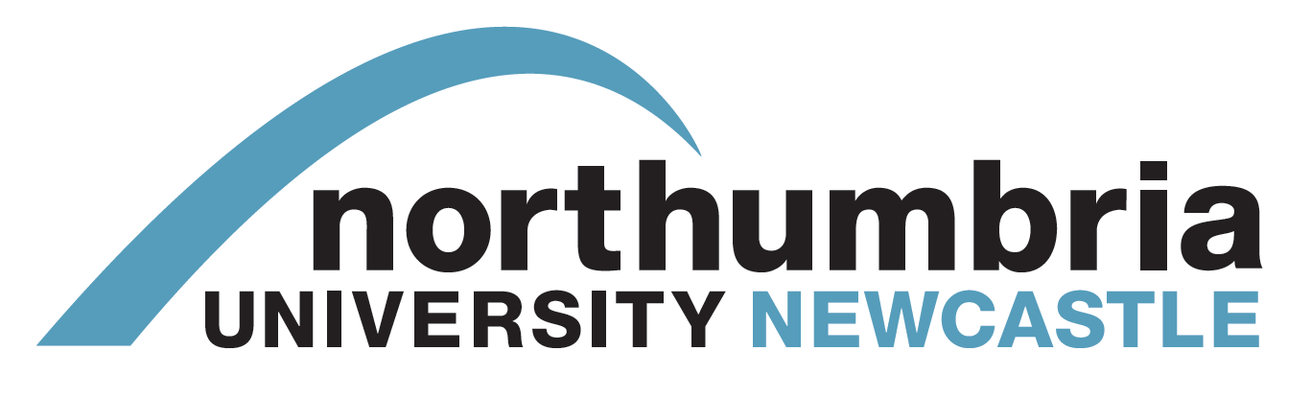

CONSENT FORM

A Taxonomy of UK Crowdfunding

and Examination of the Potential of

Trust and Empathy in Project Success

Faculty of Arts, Design and Social Sciences
Department of Media and Communication Design
Lipman Building
Newcastle upon Tyne
NE1 8ST

Please tick the appropriate boxes | Yes | No
Taking Part
I have read and understood the project information sheet dated April 2014.

I have been given the opportunity to ask questions about the project.

I agree to take part in the project. Taking part in the project will include being interviewed and audio recorded.

I understand that my taking part is voluntary; I can withdraw from the study prior to publication of any research .

Use of the information I provide for this project only
I understand my personal details such as email address, phone number and address will not be revealed to people outside the project.

I understand that my words may be quoted in publications, reports, web pages, and other research outputs.

Please choose one of the following two options:
I would like my real name used in the above
I would not like my real name to be used in the above.

________________________ _____________________ ________
Name of participant [printed] Signature Date

________________________ __________________ ________
Researcher [printed] Signature Date

Contact Dr Jo Briggs, jo.briggs@northumbria.ac.uk

This work is licenced under the Creative Commons Attribution-Non-Commercial-Share Alike 2.0 UK: England & Wales License. To view a copy of this licence, visit http://creativecommons.org/licenses/by-nc-sa/2.0/uk/

